Exercise 1: Ranking and Window Functions
QUERY:
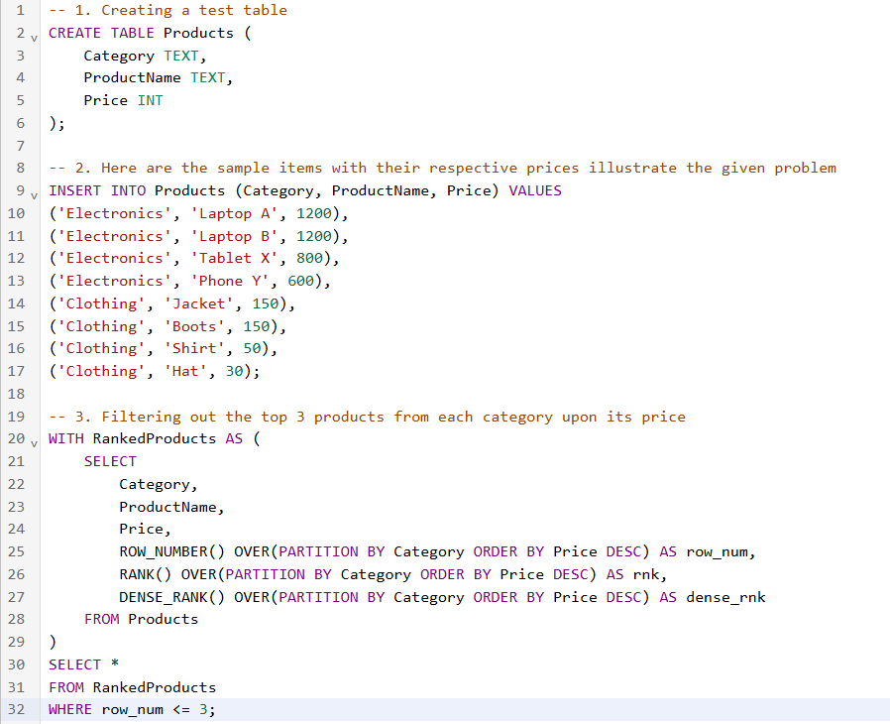
OUTPUT:
